A Simple 40m Vertical Antenna
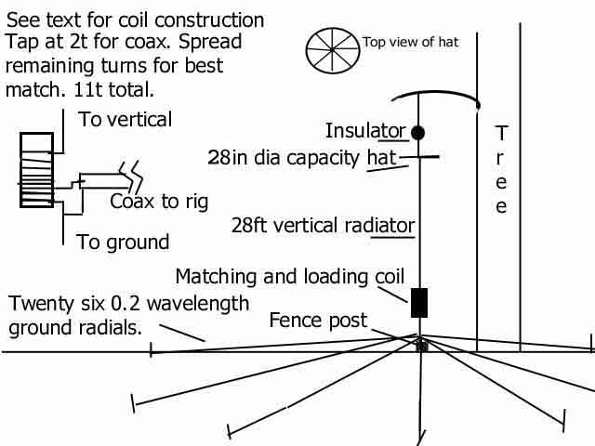
The 40m band is a great place for DXing! I don't have the tall supports needed for a dipole or beam, so a vertical antenna works best for me. I do have a convienent tree limb near my shack, and decided to build an antenna to fit.
The reports received so far have been good, with signal reports over S-9 from the Virgin Islands, S-6 from South Africa, while running 80W PEP output power.
The 28 foot vertical element, and the matching and loading coil, are made with insulated 12 AWG solid wire used for electric utility service.
The coil form is a one foot length of 2.5in. O.D. PVC pipe. Eleven turns are close-wound near one end of the form. The ends of the windings are anchored to the ends of the PVC coil form with #8 stainless steel machine screws and nuts. After mounting the coil between the vertical element and the ground radials, it's tapped at two turns from the ground end for the coax feed. The last four to five turns of the coil (nearest to the vertical element) are spread and squeezed until the best match is obtained. Then wrap the coil with electical tape to secure the windings position.
The capacity top hat and ground radials are fashioned from 14 AWG galvanized steel electric fence wire.
A metal fence post below the coil anchors it as well as the close end of the ground radials. The far end of the radials are anchored with wooden stakes.
It's not fancy, but it's quick, cheap, and easy... it works well too!
Return to the mule's ham radio index.

